Assessment 1
For all the question below, student are supposed to create Pseudocode and flowchart along with the well written code.
Question 1: 4 marks
Write a Java program that accepts user input for three friends: Sam, Aaron, and Kripa. The program should ask the user to enter the following details for each friend:
- Name, Age and weight(in decimal values)
Once the details have been entered, the program should display all the information.
Also, the program must include conditional statements to manage situations where the user enters invalid input.
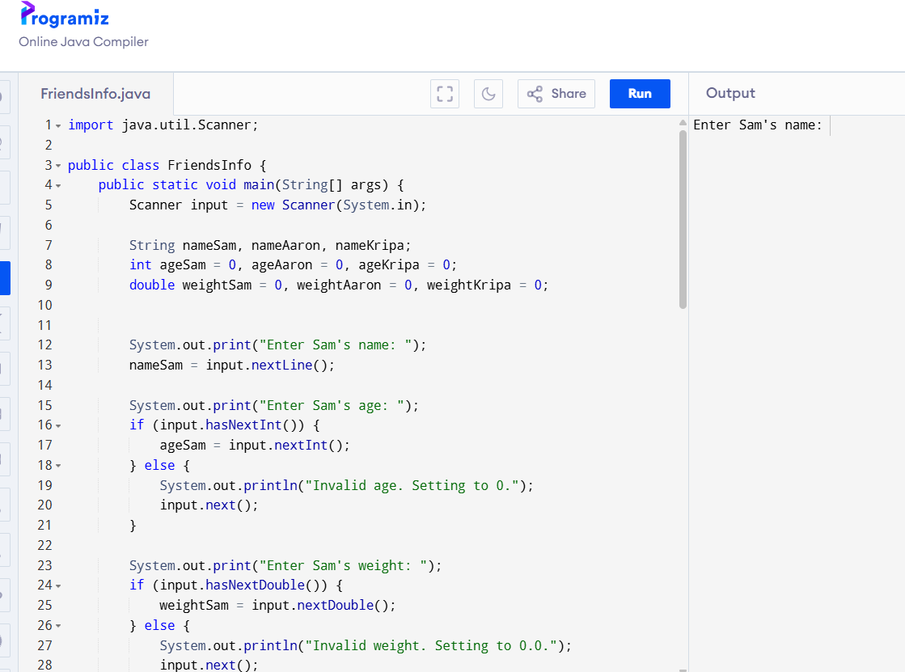
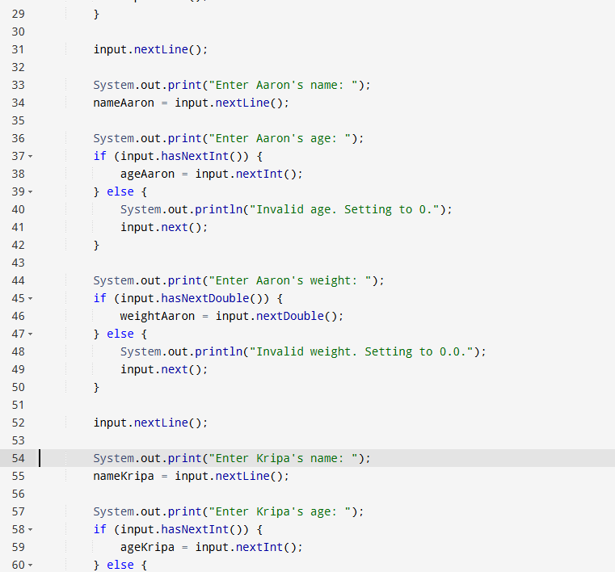
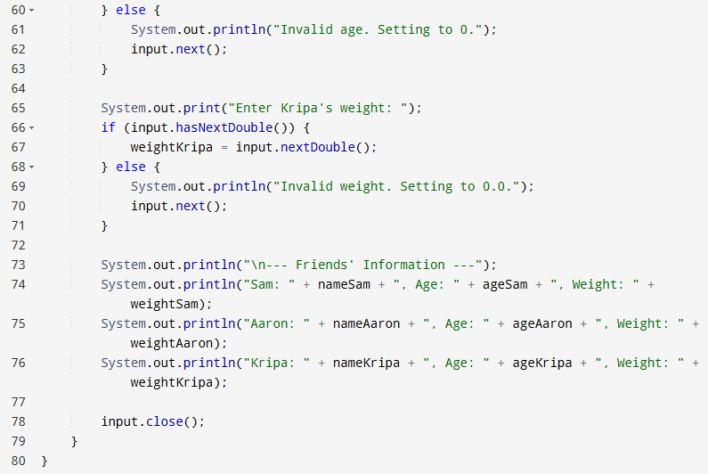
Question 2: 4 marks
Write a java program to print the following pattern using a for loops.
*
**
***
****
*****
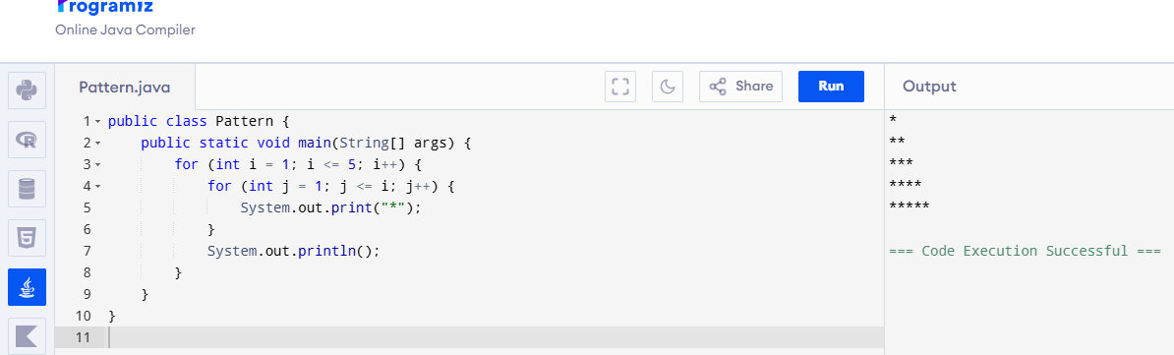

Question3: 4 marks
Write a Java Program to print he pattern using while loop .
*****
*****
*****
*****

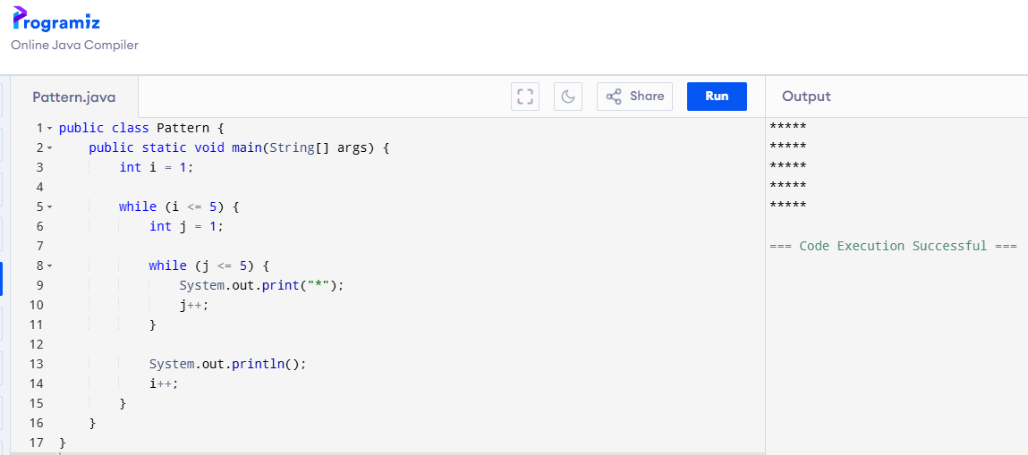

Question 4: 4 marks
Write a Java program based on the instructions mentioned below.
1. Write a program that accepts input from two friends(Ben and Peter) about their weight and height.
2. Calculate BMI for both of them.
3. Now the program should display the weight, height and BMI for both friends.
4. Now compare the BMI values for both.
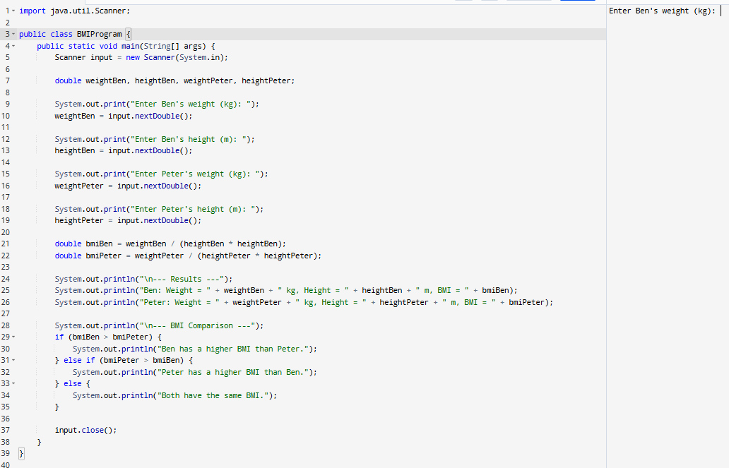

Question 5: 4 marks
Write a Java program that accepts user input to enter a student’s marks. Use if–else statements to determine and display the student’s grade according to the following criteria:
85–100 : Grade HD
75–84 : Grade D
65–74 : Grade C
50–64 : Grade P
< 50 : F
The program should also validate the user input and display an error message if the entered marks are invalid. The program should also handle cases where the user enters marks in decimal values.

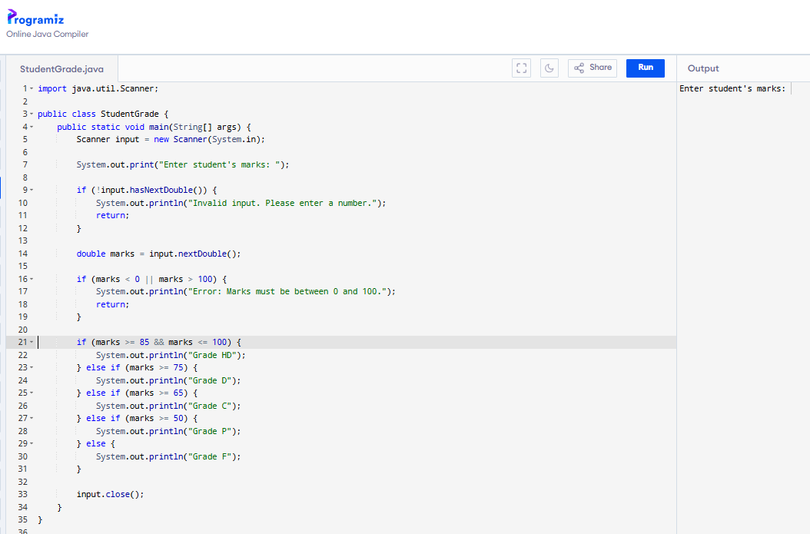
Student Reflection: 5 marks
Write structured reflection on your approach to this assessment tasks, which required you to identify what you have mastered and opportunities for improving the self-regulation of their learning.

In this learning journey I have learnt that I am capable of doing java program that accepts user input for three friends, and to print the some asterisks pattern using for loops.
Additionally, in this learning journey I recognized my mistakes and the work which I should focus on more which are java programing using if-else statements and following the instructions. So, to improvise on this task, I used the java textbook effectively and learnt some new concepts which I didn’t learn before.

